THE BRITISH INTERNATIONAL SCHOOL ISTANBUL 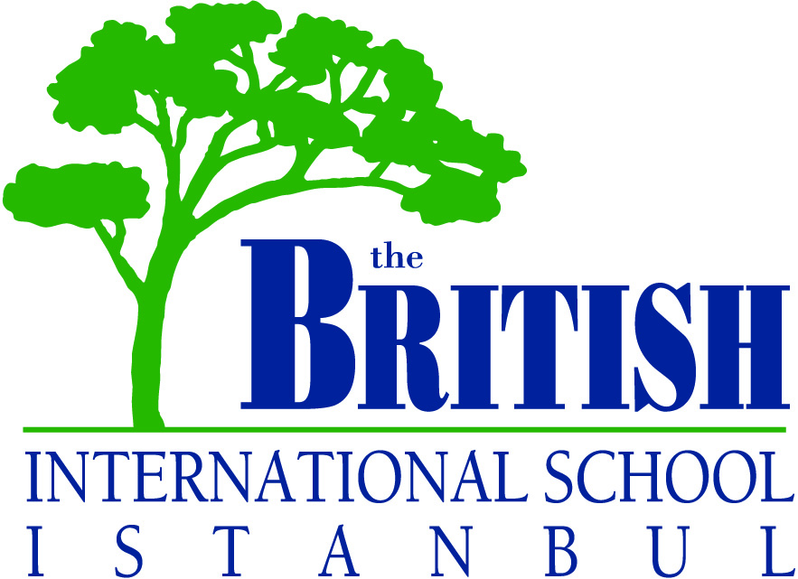

ABOUT US
The British International School Istanbul has a worldwide reputation for the education it provides. It is a leading private international School in Turkey, offering a modified English National Curriculum, IGCSE and the International Baccalaureate Diploma Programme. We are an academic school and we send our graduates to universities throughout the world, predominantly to the UK and USA.
Our ethos is welcoming and embracing. We inspire student enthusiasm, confidence, and independence and we welcome new students throughout the year. We seek to instil in all of our students an awareness and esteem of different cultures, beliefs, skills, values and personalities. As world citizens we celebrate both our shared humanity and cultural diversity. We are a co-educational community that includes students from over 55 nationalities, between the ages of 2 ½ to 18 years. We place a high emphasis upon the acquisition of languages and offer German, Spanish, French and Turkish. In addition to our foreign languages we also offer excellent support for English as a Second Language; students who join us with very limited English quickly reach the stage where they are fully able to access our curriculum.
We are non-selective and are fortunate to be able to offer full-time Special Needs Support throughout both the Primary and Secondary departments.
We have an excellent creative arts programme and offer Music, Theatre and Visual Arts in the IB Diploma Programme. We also have a very strong PE Department boasting school teams in several sports. In addition we offer an extensive range of extra-curricular activities both after school and timetabled.
Our PTA is an active body which plays a major role in the development of our school.
BISI is a happy, caring community with Parents, Students, Staff and Leadership Teams all working together to make our school great. We have a City Campus for Pre School and Primary and a purpose built campus at Zekeriyaköy for Pre School, Primary and Secondary, just four miles from the Black Sea and close to the beautiful Belgrade Forest.
Wouldn’t you like to join the BISI Community?

SCHOOL DESCRIPTION – SPECIFIC

Campuses
ALKENT |  | Primary |  | 4 - 7 years
ETİLER | Pre School | Primary |  | 2½ - 4 years / 7 - 11 years
ZEKERİYAKÖY | Pre School | Primary | Secondary | 2½ - 18 years

Hours
- Pre Schools and Primary Schools begin at 09:00 hours.
- Secondary School begins at 08:50 hours.
- All schools finish at 15:30 hours.

Pupil Teacher Ratio
Pre School | Primary | Secondary
10 – 1 | 10 – 1 | 6 – 1
(Excluding Support Teachers)

Refreshments
Students are provided with a cooked lunch, and a monthly menu is published. A morning snack is served to students and bottled drinking water is always available.

Sports
Physical Education is considered important for all students. In addition to general physical co-ordination and fitness, the following sports are included: soccer, swimming, athletics, cross-country, tennis, basketball and rugby.

Extra-Curricular Activities
A wide range of activities are on offer to students to choose from. Typically they include sports clubs, internet club, student council, school newspaper, choir, board games, needlework, art club, history club and drama.

Excursions
Turkey in general and Istanbul in particular are remarkable for their richness of geography and history. The school takes full advantage of its unique location, and educational visits occur throughout the year. In addition to these, the Secondary School run sporting, cultural and educational trips to overseas destinations throughout the year.

Uniform
School Uniform is compulsory for all students, excepting Years 12 and 13, who follow a dress code. A Uniform List is enclosed. Students are expected to conform to the school’s interpretation of modest dress.

Transport
The school nominates a company each year to transport students to and from School. While BISI provides liaison and co-ordination with the transport company, all matters relating to payment are the responsibility of parents. A Bus Registration Form is enclosed.

Playgroups
The school operates playgroups for accompanied children up to 2½ years old. These are located in Etiler and Zekeriyaköy. They carry a nominal charge.

CURRICULUM OUTLINE

Pre School
English National Curriculum: Foundation Stage 2½ to 6 years

Primary School
English National Curriculum:
Key Stage 1
4 to 5 yrs Reception
5 to 6 yrs Year 1
6 to 7 yrs Year 2

Key Stage 2
7 to 8 yrs Year 3
8 to 9 yrs Year 4
9 to 10 yrs Year 5
10 to 11 yrs Year 6

Secondary School
English National Curriculum:
Key Stage 3
11 to 12 yrs Year 7
12 to 13 yrs Year 8
13 to 14 yrs Year 9

Key Stage 4
14 to 15 yrs Year 10 IGCSE
15 to 16 yrs Year 11 IGCSE

International Baccalaureate Diploma:
16 to 17 yrs Year 12 IB
17 to 18 yrs Year 13 IB

National Equivalences

AGE | USA/CANADA | AUSTRALIA | ENGLAND | BISI
2 – 3 | Pre School | Pre School | Nursery | Pre School
3 – 4 | Pre School | Pre School | Nursery | Pre School
4 – 5 | Pre School | Pre School | Reception | Reception
5 – 6 | Kindergarten | Kindergarten | Year 1 | Year 1
6 – 7 | Grade 1 | Year 1 | Year 2 | Year 2
7 – 8 | Grade 2 | Year 2 | Year 3 | Year 3
8 – 9 | Grade 3 | Year 3 | Year 4 | Year 4
9 – 10 | Grade 4 | Year 4 | Year 5 | Year 5
10 – 11 | Grade 5 | Year 5 | Year 6 | Year 6
11 – 12 | Grade 6 | Year 6 | Year 7 | Year 7
12 – 13 | Grade 7 | Year 7 | Year 8 | Year 8
13 – 14 | Grade 8 | Year 8 | Year 9 | Year 9
14 – 15 | Grade 9 | Year 9 | Year 10 | Year 10
15 – 16 | Grade 10 | Year 10 | Year 11 | Year 11
16 – 17 | Grade 11 | Year 11 | Year 12 | Year 12
17 – 18 | Grade 12 | Year 12 | Year 13 | Year 13

